Project Documentation
E-commerce data sales report

Project Overview
This single-page executive sales dashboard in Power BI provides a high-level overview of key e-commerce metrics, including revenue, orders, and profit margins. Built on a clean 16:9 canvas with interactive slicers, KPI metric cards, and core performance charts, it enables stakeholders to analyze sales trends and customer demographics effortlessly. The scroll-free layout and optimized visual hierarchy ensure a seamless user experience suitable for executive reporting and repository portfolio showcas

2. Tools Used
- Microsoft Excel
- Power BI

3. Dataset
- Source: E-commerce sales data
- Data contains: [briefly list key columns like Date, Product, Sales, customer name ,city,brand etc..

4. Steps Followed
- Cleaned data in Excel (e.g., removed blanks, formatted columns)
- Used Excel formulas and Pivot Tables for basic analysis
- Imported cleaned data into Power BI
- Built dashboards using charts, slicers, and KPIs

5. Key Insights
- Revenue Driver Concentration
- Channel & Payment Preferences
- Geographic Sales Hubs

• Peak Sales Seasonality: Revenue spikes consistently during specific months, indicating clear seasonal purchasing trends for campaign timing.
• Profit Margin Variance: Profit margins vary significantly across categories despite high sales volumes, signaling areas for cost optimization.
• Customer Retention Impact: A small percentage of repeat customers contributes disproportionately to total orders, proving high long-term value.

6. Screenshots
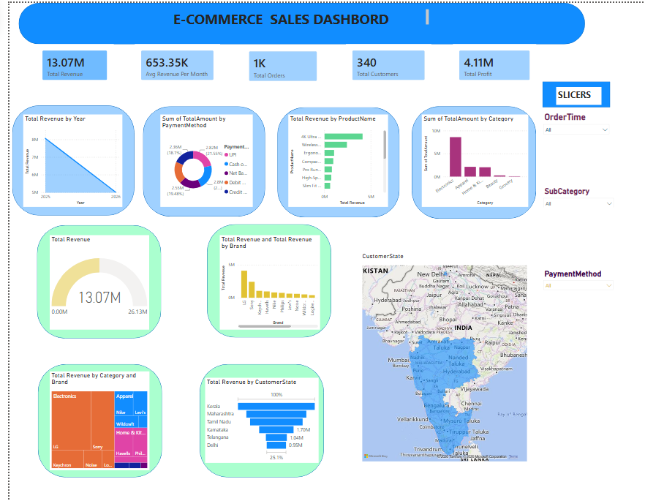

7. Files Included
- Ecommerce_master_dataset_large clean dataset – Cleaned data and basic analysis
- Mini project sales report– Power BI dashboard

8. How to Use
- Open ` Ecommerce_master_dataset_large clean dataset ` to view the cleaned data.
- Open ` Mini project sales report ` in Power BI Desktop to explore the visuals.

